

**Purbanchal University**

**College of Information Technology & Engineering**

**Subidhanagar, Tinkune, Kathmandu**

Project Report

On

**Attendance Payroll Management System**

**Submitted by**

Raman Chaudhary (350567)

Sujan Thapa (350574)

Anish Chaudhary (350558)

Batch: 2020

Faculty: Science & Technology

Program: BIT

**Submitted to**

Department of science and technology

**LETTER OF APPROVAL**

We, the supervising committee of CITE College, have successfully supervised and Approved the Project report entitled “Attendance Payroll Management System” submitted by Project the members (Raman Chaudhary, Anish Chaudhary & Sujan Thapa), BIT-V Semester. During our supervising period, we found that the corresponding report has been prepared as approved by the department in prescribed format of Bachelor of Information Technology (BIT), Faculty of Science & Technology. This report is forwarded to the further Examination.

With best regards,

……………………… ………………………

Project Supervisor Internal Examiner

………………………

External Examiner

**ACKNOWLEDGEMENT**

With immense please, we are presenting “Attendance Payroll Management System” report as part of curriculum “Bachelor of Information Technology”. We wish to thank all the people who gave us unending support.

We express our profound thanks to our Academic Director Mr. Saroj Dahal, Project Supervisor (Mr. Suman Dhital) & other’s all those who have indirectly guided and helped us to build this project.

We would like to thank Purbanchal University (PU) as well as College of Information Technology & Engineering (CITE) for the course and the project assigned which helped in our study and developing skills like code and project management.

**ABSTRACT**

The objective of this paper is to provide an Attendance Payroll Management System (APMS) within an organization. In an era of rapidly evolving technological advancements, the integration of an effective APMS has become imperative for organizations striving to optimize their human capital management processes.

Attendance Payroll Management Systems (APMS) streamline salary processing, and compliance tasks. They automate workflows, minimize errors, and offer insights into labor costs. Implementation involves system Attendance, schedule for work, Position, and payment record. APMS benefits include improved accuracy, compliance, and resource optimization. Future trends include cloud integration and AI enhancements, promising greater accessibility and intelligence. In essence, APMS facilitate efficient payroll management, compliance, and strategic HR focus.

[*Keywords: Attendance management, Admin authentication, Employee database, Employee Record keeping, Overtime management, Payroll management, Shift Scheduling, Salary calculation*]

**Contents**

Chapter 1: Introduction 1

1.1 Introduction of APMS 1

1.2 Problem Statement 2

1.3 Objectives 2

1.4 Motivation 2

1.5 Applications 3

1.6 Scope 3

1.7 Feasibility Study 4

1.7.1 Technical Feasibility 4

1.7.2 Economic Feasibility 4

1.7.3 Operational Feasibility 5

1.8 Requirement Specifications 5

1.8.1 Tools & Technologies 5

Chapter 2: Literature Review 11

2.1 Study on Existing Systems 11

2.2 Relevance of Literature Review with Project 12

Chapter 3: Design Methodology 13

3.1 Waterfall Model 13

Chapter 4: Implementation 16

4.1 ER Diagram 16

4.2 Flowchart 18

4.3 Team Structure 19

4.4 Implementation Details 19

4.5 DFD Diagram 21

4.6 Gantt Chart 22

4.7 Testing of System 23

4.7.1 White Box Testing 23

4.7.2 Black Box Testing 25

Chapter 5: Conclusion 26

5.1 Limitations 26

5.2 Future Enhancement 26

References 27

Appendix 29

**List of Tables**

Table 1: Team Structure 19

Table 2: Implementation Details of APMS 21

Table 3: White Box Testing of APMS 24

Table 4: Black Box Testing of APMS 25

**List of Figures**

Figure 1: Waterfall Model 14

Figure 2: ER Diagram of APMS 17

Figure 3: Flowchart of APMS 18

Figure 4: Level 0 dfd 21

Figure 5: Gantt Chart 22

Figure 6: Admin login page 29

Figure 7: Employee attendance page 29

Figure 8: Dashboard 30

Figure 9: Attendance list 30

Figure 10: Deduction details 31

Figure 11: Employee payroll list 31

Figure 12: Employee payroll 32

Figure 13: Employee payment slip 1 32

Figure 14: Employee payment slip 2 33

Figure 15: Admin table 33

Figure 16: Employee table 33

**List of Abbreviations**

APMS: Attendance Payroll Management System

HR: Human Resource

UI: User Interface

HRM: Human Resource Management

ERD: Entity Relationship Diagram

DFD: Data Flow Diagram

SDLC: Software Development Life Cycle

HDD: Hard Disk Drive

SSD: Solid State Drive

HTML: Hypertext Markup Language

CSS: Cascading Style Sheets

IDE: Integrated Development Environment

PHP: Hypertext Preprocessor

JS: JavaScript

SQL: Structured Query Language

# Chapter 1: INTRODUCTION

## 1.1 Introduction of APMS

An APMS is a program used to streamline and manage employee payments according to their attendance. It manages the attendance of the employees in an organization and calculates the total payment of the employee from working hours which helps in generating pay slip of his/her work effort. The payroll system frees up human resource teams to do other tasks, such as planning and budgeting. APMS covers almost all aspects which is related to the attendance of the employee. APMS is an outcome of hard work done by our project members in supervision of our supervisor sir which includes many fields such as (attendance, dashboard, Employee’s record, overtime work, cash advances, positions, payroll, etc.). Our project works mainly from admin side and for employee the attendance board is shown where he/she can do check in and check out. The APMS will have a web-based interface to allow employees to enter timecard information, and create various reports such as payment slip. The system will run on individual’s employee desktops throughout the entire company for only attendance and the controller desktop will be admin. Almost every works that is to be done in organization for attendance is covered by our system so it will be fruitful to use in an organization.

APMS streamline path of working flow in an organization by taking care of following functions:

* Deduction, Position, Schedule Data Record
* Performance Management such as on time performance, late today, overtime
* Attendance of Employee
* Payroll Management

## 1.2 Problem Statement

In today's rapidly evolving business world, organizations are facing a lot of challenges for effectively managing their employee attendance & payment methods. These systems help companies efficiently manage employee salaries, deductions, and other payroll-related tasks. As part of the payroll system, the HR department must compute every employee’s attendance, overtime, cash advances, etc. Unfortunately, the manual recording of this data is prone to errors, making it extremely frustrating for staff to fix them. This data mistake impacts their pay, as some employees get less, and others get more than they are entitled to. An Attendance payroll management system keeps track of attendance, overtime and advances without maintaining a pile of documented files. (Kredily, 2024)

Lastly, the available commercial systems in the market tend to come with exorbitant price tags, making them financially burdensome for many organizations. Addressing these issues and developing a more streamlined and cost-effective solution is imperative for enhancing the overall efficiency and effectiveness of university management.

## 1.3 Objectives

The objectives which we want to achieve through this project are given below:

* To manage attendance and calculate payments for employees.
* To develop user friendly interface for admin.

## 1.4 Motivation

APMS is the system which is used to efficiently handle and manage records of employees and generate the pay slip with the working time dynamically. It helps organization to maintain attendance and payroll system in easy way.

Before developing this project, we have seen the problem facing by the organization and employees with the traditional way of keeping attendance and records which is time consuming and not effective. With the manual record keeping errors and management is headache. So, we have made this system which covers these mentioned problems facing by the employees and organizations. Hence, main aim is to develop efficient, cost effective and time saving system for attendance payroll.

## 1.5 Applications

* **Employee information management such as records, overtime, cash advance and schedule:** These all are done to make our system efficient and manage employees by admin with full control over the system to do every work needed.
* **Attendance Tracking:** Employees can time in and time out with their scheduled time or when they are present. When employees are checked in then our system will automatically track attendance and display data dynamically about status of attendance.
* **Payment slip:** In our system payment is given on monthly basis so, payment slips are generated by automatically tracking working hours done by employee in a day.
* **Schedule print:** The schedules which are maintained in our system can be printed out if needed for any type of job openings advertisements or if any employee needs it.

## 1.6 Scope

This project deals with the various functions in the employee attendance and payment management process. The main idea is to implement a proper process to system. In existing system’s which contains many operations like Attendance, Performance records, Payroll, Employee records, Schedule. All these activities are takeout manually by administrator.

Another main scope of our project is in context of small organizations, many organizations are just using manual file-based record keeping and manual payment-based method due to the high cost of the existing software’s used for this, so we have come with the system that helps to minimize this as it can be installed within very low cost and easy to handle which by anyone. So, in future this system can be integrated with HR system and put in operations for organizations for better functionality.

## 1.7 Feasibility Study

A feasibility study is an assessment of the practicality of a project or system. A feasibility study aims to objectively and rationally uncover the strengths and weaknesses of an existing business or proposed venture, opportunities and threats present in the natural environment, the resources required to carry through, and ultimately the prospects for success. In its simplest terms, the two criteria to judge feasibility are cost required and value to be attained. (Simplilearn, 2024)

From all the study done regarding the feasibility of the proposed system, it can be said that the system is slightly feasible. Feasibility study on the project can be categorized in the following:

### Technical Feasibility

Technical feasibility is the process of figuring out how you're going to produce your product or service to determine whether it's possible for your company. Before launching your offerings, you must plan every part of your operations, from first sourcing your production materials all the way to tracking your sales. (Indeed, 2024)

Our project team has the technical infrastructure and resources to support the development and operation of the APMS. This includes evaluating compatibility with existing systems, availability of necessary hardware and software, and technical expertise within the organization or available from vendors.

### Economic Feasibility

Economic feasibility refers to the ability of a project or business venture to generate enough revenue to cover its costs and provide a reasonable return on investment. It involves analyzing the costs and benefits of a project, including the costs of materials, labor, and equipment, as well as the projected revenue from sales or other sources of income. (Cambridge Dictionary, 2024)

Determining the financial resources required for acquiring, implementing, and maintaining the APMS. Here, we have estimated costs related to software licenses, hardware upgrades, customization, and ongoing support. We have also compared these costs with potential savings and benefits to ensure a that our system is cost effective or not.

### Operational Feasibility

Operational feasibility is the measure of how well a proposed system solves problems and takes advantage of the opportunities identified during scope definition and how it satisfies the requirements identified in the requirements analysis phase of system development. (Lawinsider, 2024)

Evaluating whether the organization's operations and processes can effectively incorporate the APMS. Our project will solve the problem of the organizations related to attendance and payroll and make run processes effectively.

## 1.8 Requirement Specifications

### 1.8.1 Tools & Technologies

This section typically includes a detailed list of the software, hardware, programming languages, frameworks, libraries, and any other tools used during the development and implementation of the project. This section provides readers with valuable insight into the technological infrastructure and resources utilized to accomplish the project objectives. Here are some common elements that may be included in the Tools & Technologies section:

#### 1.8.1.1 Software Requirements

For this project, which is developed and operated on the Windows 8 or higher operating system and is hosted on an Apache server, the development is primarily facilitated by a combination of HTML, CSS, and JS for the front end, ensuring a visually appealing and interactive user interface. The VS Code IDE (Visual Studio Code) is utilized for coding and development tasks, providing an intuitive and efficient development environment. For hosting, we have used XAMPP server Apache. The backend functionality is implemented using PHP, enabling dynamic content generation and interaction with the MySQL database for efficient data management.

#### 1.8.1.2 File Extensions

We have used file extensions such as “.php” for storing php scripts, “.css” for styling the web page, “.js” for the scripts which helps to make the webpage UI dynamic and others like .jpg, .png etc. for the images used in the project.

#### 1.8.1.3 Hardware Requirements

Considering the contemporary computing environment, the hardware requirements for optimal performance are set accordingly. As this project is developed in today’s world needs matchable computer so, we have set requirements as per our system developed devices. The hardware requirements for our project are (i3 or higher) level processor because modern computer’s support new updated browsers so, to support these browsers functions at the best device must have new functions as we have stated. To support system to run perfectly device must have minimum RAM of 2GB and if available then HDD or SSD of minimum 128GB for the better performance.

#### 1.8.1.4 Overview of Front End

An important issue for the development of a project is the selection of suitable front- end and back-end. When we decided to develop the project, we went through an extensive study to determine the most suitable platform that suits the needs of the organization as well as helps in development of the project.

The aspects of our study included the following factors for Front-end selection:

* It must have an interactive graphical user interface that assists employees that are not from computer background.
* Scalability and extensibility.
* Flexibility.
* Robustness.
* According to the organization requirement and the culture.
* Must provide excellent reporting features with good printing support.
* Platform independent.
* Easy to debug and maintain.
* Front end must support some popular back end like MySQL.

According to the above stated features we have chosen HTML, CSS, JS, & Bootstrap framework to develop the front-end part.

1. **HTML**

HTML (Hypertext Markup Language) is the standard markup language used to create the structure and content of web pages. It provides a set of tags that define various elements such as headings, paragraphs, images, links, and forms. HTML serves as the backbone of web development, providing the foundation upon which web pages are built.

1. **CSS**

CSS (Cascading Style Sheets) is a stylesheet language used to control the presentation and layout of HTML elements on a web page. With CSS, developers can define styles such as colors, fonts, margins, padding, and positioning to enhance the visual appearance and aesthetics of a website. CSS allows for separation of content from presentation, making it easier to maintain and update the design of a website.

1. **JS**

JavaScript (JS) is a programming language commonly used for client-side scripting in web development. It enables interactive and dynamic behavior on web pages, allowing for features such as form validation, interactive forms, image sliders, and more. JavaScript can manipulate HTML and CSS in real-time, enabling developers to create responsive and interactive web applications.

1. **Bootstrap**

Bootstrap is a popular front-end framework for developing responsive and mobile-first websites and web applications. It provides a collection of pre-designed HTML, CSS, and JavaScript components, including navigation bars, buttons, forms, modal dialogs, and more. Bootstrap streamlines the development process by offering a consistent and customizable set of UI components that are responsive and optimized for various screen sizes and devices. By leveraging Bootstrap, developers can create modern and visually appealing websites with minimal effort and time.

#### 1.8.1.5 Overview of Back End

For Back End Selection we have analyzed the available tools by looking on below factors:

* Multiple user support.
* Efficient data handling.
* Provide inherent features for security.
* Efficient data retrieval and maintenance.
* Stored procedures.
* Popularity.
* Operating System compatible.
* Easy to install.
* Easy to implant with the Front-end.

According to above stated features we selected MySQL as the backend, Apache server for hosting our site and PHP as the backend scripting language.

The technical feasibility is frequently the most difficult area encountered at this stage. It is essential that the process of analysis and definition be conducted in parallel with an assessment to technical feasibility. It centers on the existing computer system (hardware, software etc.) and to what extent it can support the proposed system.

1. **About MySQL & SQL**

SQL is Structured Query Language, which is a computer language for storing, manipulating and retrieving data stored in a relational database. SQL is the standard language for Relational Database System. All the Relational Database Management Systems (RDMS) like MySQL, MS Access, Oracle, Sybase, Informix, Postgres and SQL Server use SQL as their standard database language.

MySQL is an open-source tool that’s used to manage data stored within servers and databases. As one of the most popular database management tools available, MySQL has become the industry standard thanks to its highly customizable and easy to use nature. It’s also incredibly secure and compatible with all the major operating systems, including Windows, Mac and Linux. It handles a large subset of the functionality of the most expensive and powerful database packages. MySQL uses a standard form of the well-known SQL data language. MySQL works on many operating systems and with many languages including PHP, PERL, C, C++, JAVA, etc.. (Oracle, 2024)

1. **Apache Server**

Apache HTTP Server, commonly referred to as Apache, is an open-source web server software widely used for serving web content over the Internet. It is highly customizable and extensible, offering robust features for hosting websites, applications, and services. Apache supports various operating systems, including Unix-based systems like Linux and BSD, as well as Windows. It is known for its stability, security, and scalability, making it the preferred choice for hosting millions of websites worldwide. Apache's modular architecture allows for easy integration with additional modules and extensions, enabling developers to customize and optimize server functionality to suit their specific needs. With its flexible configuration options and strong community support, Apache remains a cornerstone of web server technology. (Apache, 2024)

1. **PHP**

PHP (Hypertext Preprocessor) is a server-side scripting language designed for web development and general-purpose programming. It is widely used for creating dynamic web pages and web applications, where PHP code is executed on the server to generate HTML content dynamically before being sent to the client's web browser. PHP is known for its simplicity, flexibility, and ease of integration with other technologies, making it a popular choice for web development. It offers a wide range of features, including database connectivity (e.g., MySQL, PostgreSQL), file handling, form processing, session management, and more. PHP is supported by most web servers, including Apache, Nginx, and Microsoft IIS, and it can be embedded directly into HTML or used as a standalone script. With its vast ecosystem of frameworks, libraries, and tools, PHP empowers developers to build robust and scalable web applications efficiently. (W3 Schools, 2024)

To create our interactive website project, a combination of all above stated requirements such as PHP, HTML, CSS, JavaScript, Bootstrap, SQL, and an Apache server has been utilized combinedly. HTML is used to create the structure of the web pages, defining the layout and content elements. CSS is employed to style and design these elements, ensuring a visually appealing presentation. JavaScript have been used to add interactivity to the website by enabling dynamic features such as form validation, animations, and user interface enhancements. Bootstrap, a front-end framework, is used to streamlines development with its pre-designed components and responsive grid system, ensuring the website looks great on various devices. PHP is used to serve as the server-side scripting language, facilitating dynamic content generation, data processing, and interaction with the SQL database. SQL is used for database management, allowing storage and retrieval of data essential for the website's functionality. Finally, the Apache server is used to hosts the website, delivering content to users' browsers and handling requests seamlessly. Collectively, these technologies are used to create a cohesive ecosystem enabling the development of modern, interactive websites that engage users effectively.

# Chapter 2: literature review

## 2.1 Study on Existing Systems

To understand more about the Attendance Payroll Management System, we have analyzed the existing systems documentations found in the internet. There are huge numbers of documentation found and some of which we have studied are as follows:

This human resource management (HRM) system integrated different theoretical perspectives and investigated how, when, and why HRM systems influence different types of firm innovation. Moreover, this paper presented the current dilemma and future research directions in the field of HRM systems and firm innovation. This system has analyzed existing system using the waterfall model leading to the design and development of an online employment registration system which does not require the physical presence of employees. (Zhang, 2023)

This “Payroll Management System” was designed to automate the existing manual system using computerized equipment and cutting-edge computer software, meeting client’s needs so that their valuable data and information can be stored for a longer period with easy access and manipulation. The necessary software is readily available and simple to use. This software allows users to keep track of and see computerized records without having to make duplicate entries. The project explains how to handle user data for optimal efficiency and better customer service. (ITsourcecode, 2024)

Attendance & Payroll are critical to every organization, no matter what their size or scale of operation or which industry they operate in. After all, properly managing attendance and payroll ensures that employees are paid accurately on time while being compliant to all regulatory requirements. Further, they help maintain productivity, track performance and ensure better allocation of resources. Proper payroll and attendance management also help improve transparency and accountability within the organization. Attendance and payroll are two crucial aspects of the HR function. But they aren’t restricted to the HR department alone; they require collaborative efforts from both the HR and finance departments. In some cases, the organization may have separate payroll teams that will have to collaborate with the HR and finance teams for the effective management of payroll and attendance. (Tankhapay, 2024)

This “Employee Database and Payroll Management System” was designed to make the existing manual system automatic with the help of computerized equipment and full-edged computer software, fulfilling their requirements, so that their valuable data and information can be stored for a longer period with easy access and manipulation of the same. The required software is easily available and easy to work with. This web application can maintain and view computerized records without getting redundant entries. The project describes how to manage user data for good performance and provide better services for the client. This proposed project “Employee Database and Payroll Management System” has been developed to overcome the problems faced in the practicing of manual system. This software was built to eliminate and, in some cases, reduce the hardships faced by the existing system. Moreover, this system was designed for particular need of the company to carry out its operations in a smooth and effective manner. (Rozario, 2018)

This study on “payroll management in a business organization” was focused to examine the relationship of employee’s payment and employee’s satisfaction. The study explains that the payment system was managed with a computerized system called payroll system. Employees are paid salary after adjusting for deductions and allowances. The problem in the existing system is the preparation of revised attendance due to assumed attendance. Employee’s payments have two main components- Direct and Indirect payments in the form of wages, salaries, incentives, commissions, and bonuses, and there are indirect payments in the form of financial benefits like employer-paid insurance and vacations. (KN & Verma, 2016)

## 2.2 Relevance of Literature Review with Project

All the projects and documents we have analyzed are almost similar in some sense. They have used PHP programming with database connection for the records of employment and their enrollment. As well our project “Attendance Payroll Management System” also uses the same method for the all of our activities which we will do in it. We have used the concept of all projects which we have analyzed & applied in our project which are possible to integrate.

# Chapter 3: design methodology

Design methodology refers to the development of a system or method for a unique situation. Today, the term is most often applied to technological fields in reference to web design, software or information systems design. The key to design methodology is finding the best solution for each design situation, whether it be in industrial design, architecture or technology. Design methodology stresses the use of brainstorming to encourage innovative ideas and collaborative thinking to work through each proposed idea and arrive at the best solution. Meeting the needs and wants of the end user is the most critical concern. Design methodology also employs basic research methods, such as analysis and testing. (Learn, 2024)

For our project, as a part of project we have chosen one of the mostly used model to make the small system which is waterfall model.

## 3.1 Waterfall Model

The waterfall model is a breakdown of project activities into linear sequential phases, meaning they are passed down onto each other, where each phase depends on the deliverables of the previous one and corresponds to a specialization of tasks. The approach is typical for certain areas of engineering design. In software development, it tends to be among the less iterative and flexible approaches, as progress flows in largely one direction ("downwards" like a waterfall) through the phases of conception, initiation, analysis, design, construction, testing, deployment and maintenance. The waterfall model is the earliest SDLC approach that was used in software development. All these phases shown below are cascaded to each other in which progress is seen as flowing steadily downwards (like a waterfall) through the phases. The next phase is started only after the defined set of goals are achieved for previous phase and it is signed off, so the name "Waterfall Model". (Tutorials Point, 2024)

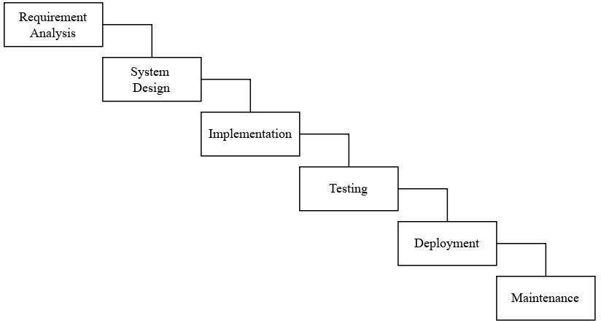

Figure 1: Waterfall Model

We have used the waterfall model which moves from top to bottom as mentioned above to complete our project. We have chosen this model because it divides the project into sequential and distinct phases, such as requirements gathering, design, implementation, testing, deployment, and maintenance & Each phase is assigned with one task which must be completed before moving on to the next, which makes the project development easier for the beginners like us.

At the very first stage when we have chosen the topic of our project & we get engaged in gathering requirements which are necessary for the completion of our project such as using languages (PHP, JS, HTML, CSS, MySQL database, effective and easy IDE (VS Code), and other frameworks such as Bootstrap, jQuery, etc.). we have also gathered the required functions of the website through research process.

When all the requirements are gathered by us, we have started to design the system i.e., our project "APMS”. We have given continuous effort until our project is fully finished. We have also left some section which are not got developed as our requirements gathering and thought of develop it later at the time of fully completion of project.

When our project got ready then we have implemented it and tested to see as it works correctly or not. This implementation and testing contain of many methods which we will cover at the implementation phase.

After testing is complemented, we have run our project in our computer browser to see how it works and also, we have continuously kept maintaining it whenever we see any errors or bugs in it or if we have to add some more features.

At summary, our project APMS was initiated with the selection of necessary technologies (PHP, JS, HTML, CSS, MySQL) and frameworks (Bootstrap, jQuery). Requirements were meticulously gathered, and the system was designed accordingly. While some sections were left for future development, continuous effort was invested until completion. Implementation and testing followed, ensuring functionality and correctness. Regular maintenance was conducted post-implementation, addressing errors, bugs, and feature enhancements as necessary. Overall, the project followed a systematic approach from conception to maintenance, ensuring its effectiveness and reliability.

# chapter 4: IMPLEMENTATION

Project implementation is the process of putting a project plan into action to produce the deliverables, otherwise known as the products or services, for clients or stakeholders. It takes place after the planning phase, during which a team determines the key objectives for the project, as well as the timeline and budget. Implementation involves coordinating resources and measuring performance to ensure the project remains within its expected scope and budget. It also involves handling any unforeseen issues in a way that keeps a project running smoothly. (Indeed, 2024)

## 4.1 ER Diagram

An ER diagram is a visual representation of entities, attributes, and relationships between them in a database. The ER diagram consists of several components including entities, attributes, and relationships. Relationships describe how entities are related to one another, and can be categorized as one-to-one, one-to-many, or many-to-many relationships. It helps to understand the system processes and data in an easy and effective way.

Entity relationship diagrams provide a visual starting point for database design that can also be used to help determine information system requirements throughout an organization. After a relational database is rolled out, an ERD can still serve as a reference point, should any debugging or business process re-engineering be needed later. However, while an ERD can be useful for organizing data that can be represented by a relational structure, it can't sufficiently represent semi-structured or unstructured data. It's also unlikely to be helpful on its own in integrating data into a pre-existing information system. (Tech Target, 2024)

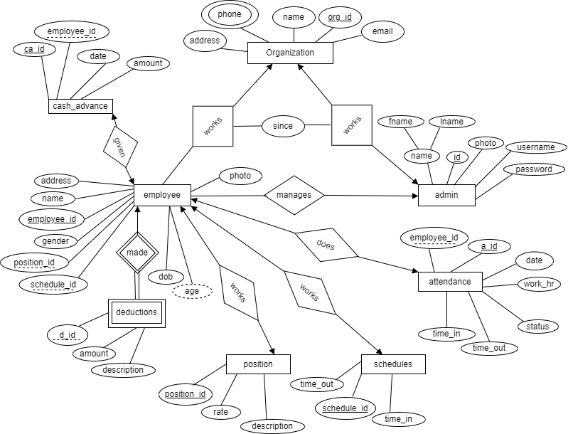This below given ER diagram shows the whole connections and structure of our project APMS database.

Figure 2: ER Diagram of APMS

## 4.2 Flowchart

A flowchart is a diagram depicting a process, a system or a computer algorithm. It is a diagrammatic representation of the solution to a given problem but, more importantly, it provides a breakdown of the essential steps to solving the problem. When designing and planning a process, flowcharts can help you identify its essential steps and simultaneously offer the bigger picture of the process. It organizes the tasks in chronological order and identify them by type, e.g., process, decision, data, etc. Each step is independent of implementation as the flowchart only describes what should happen at that step, what input is needed and what the output of the step is but it says nothing about how to implement the step. (UCL, 2024)

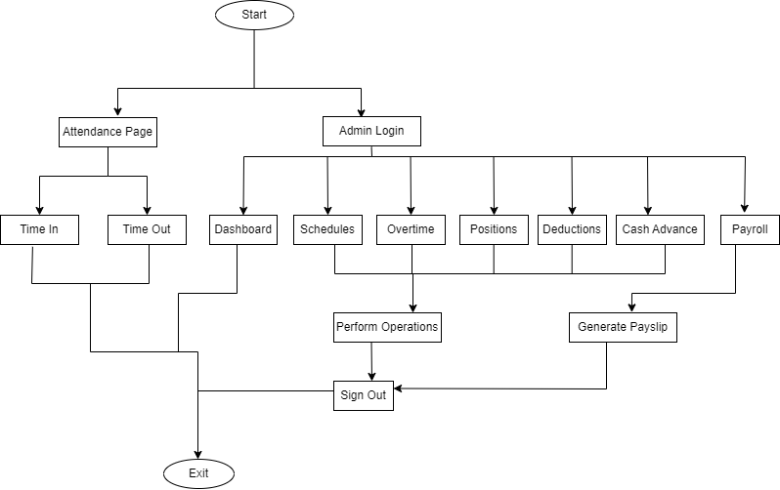

Figure 3: Flowchart of APMS

## 4.3 Team Structure

|  |  |  |
| --- | --- | --- |
| **Team Members** | **Symbol No.** | **Task done** |
| Sujan Thapa | 350574 | Research, Coding, Debugging, simulation, hardware connection & Documentation |
| Raman Chaudhary | 350567 | Research, Coding, Debugging, simulation, hardware connection & Documentation |
| Anish Chaudhary | 350558 | Research, Coding, Debugging, simulation, hardware connection & Documentation |

Table 1: Team Structure

## 4.4 Implementation Details

We have used “.php”, “.css” and “.js” extension to store the code written for this project for different features.

|  |  |
| --- | --- |
| Files | Description |
| attendance (read, add, edit, delete).php | These files contain all the CRUD operations performed in attendance section. |
| deduction (read, add, edit, delete).php | These files contain all the CRUD operations performed in deduction section. |
| cashadvance (read, add, edit, delete).php | These files contain all the CRUD operations performed in cash advance section. |
| employee (read, add, edit, delete).php | These files contain all the CRUD operations performed in employee section. |
| overtime (read, add, edit, delete).php | These files contain all the CRUD operations performed in overtime section. |
| position (read, add, edit, delete).php | These files contain all the CRUD operations performed in position section. |
| schedule (read, add, edit, delete).php | These files contain all the CRUD operations performed in the schedule section. |
| conn.php | This file contains the database connection code. |
| index.php | It contains the code and html structure for the very first opening UI page of the project. |
| login.php | It contains the code for the admin login part of the project. |
| logout.php | It contains the code for the admin logout part of the project. |
| home.php | It is the main file of our project which contains main UI for the admin part called as dashboard. |
| .js & .css files | This part of the project contains all the styling and making content dynamic codes. |
| header, menubar, footer.php | This part contains code for the header, footer and menu bar section which are displayed in each page of the website. |

Table 2: Implementation Details of APMS

## 4.5 DFD Diagram

DFD is the abbreviation for Data Flow Diagram. The flow of data of a system or a process is represented by DFD. It also gives insight into the inputs and outputs of each entity and the process itself. DFD does not have control flow and no loops or decision rules are present. Specific operations depending on the type of data can be explained by a flowchart. It is a graphical tool, useful for communicating with users, managers and other personnel. it is useful for analyzing existing as well as proposed system. (Geeksforgeeks, 2024)

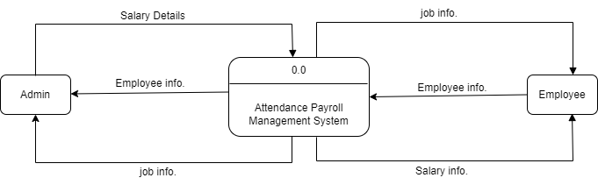

Figure 4: Level 0 dfd

Above level 0 dfd diagram shows the overview of the system and its interactions with external entities. It shows the high-level processes within our project and how they interact with each other.

## 4.6 Gantt Chart

A Gantt chart is a project management tool that helps in planning, scheduling and monitoring a project. Using a Gantt chart can improve your planning and scheduling, remote work collaboration, resource allocation and task delegation. A Gantt chart represents all information visually through a horizontal bar graph. Project managers and team members can view the task schedules, dependencies and progress by just glancing at the chart. Planning for all tasks in advance and making them visible in one place empowers teams to deliver on time. Gantt charts make it easy for project managers to identify the critical path to project completion and ensure that there is no delay in those tasks. Project managers should use Gantt charts for project planning and scheduling, allocating resources, tracking the progress of each task at all times and ensuring the smooth and timely execution of critical tasks. (Forbes, 2024)

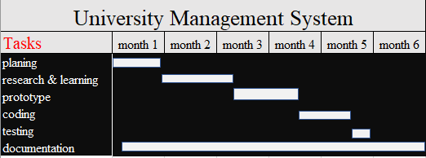

**Attendance Payroll Management System**

Figure 5: Gantt Chart

Above Gantt chart shows the progress of our project in 6 months period. There we have done project with 5 different sections such as (planning, research & learning, prototype, coding, testing, documentation).

## 4.7 Testing of System

### 4.7.1 White Box Testing

In this testing we have seen test cases such as data successfully saved in database or not, pay slip generator is successfully working or not, employee attendance percentage calculator, etc.

|  |  |  |  |  |
| --- | --- | --- | --- | --- |
| No. | Test Objective | Test Step | Expected Result | Result |
| 1. | To ensure data submitted by the admin to register employee are saved successfully in database or not. | All fields are filled and submitted for the registration. | Registration must be successful if all data entered are valid and data’s must be saved in respective table in database. | pass |
| 2. | To ensure pay slip generator function works perfectly and generates the pay slip as per the employees working hours correctly. | All the employees are checked in and checked out for the attendance and generated the pay slip with making some deductions and cash advance deductions from some employee’s salary. | Pay slip must be generated of all the employee’s as per their working hours and rate and deductions must be done for all the employees and cash advance deductions for the employees who have taken loan amount as cash advance from organization. | Pass |
| 3. | To ensure employee attendance percentage calculator and status reader functions works perfectly to show result in dashboard. | All the employees are checked in and checked out for the attendance. | If employees attain with late time, then the employee must be shown in late attendance list, if employee attains within the time, then must be shown in on time attendance list and must calculate the percentage of on time attendance list for the knowing how the employees are attaining company. | pass |
| 4. | To ensure added schedule and position are fetched by the developed function in and successfully shown as the option for choosing in respective field while adding employee. | Numbers of employees are added and, in the position, and schedule field respective data is chosen from displayed list in that field. | In position & schedule field of the employee add form the data stored in the database must be automatically fetched and shown for options to choose. | pass |

Table 3: White Box Testing of APMS

### 4.7.2 Black Box Testing

In this testing we have seen the test cases such as login, logout, schedule add, employee shown in employee list or not, etc.

|  |  |  |  |  |
| --- | --- | --- | --- | --- |
| No. | Test Objective | Test step | Expected Output | Result |
| 1. | To ensure login of the admin becomes successful. | All fields are filled and submitted for the Login. | Login should be successful if credentials are correct and the UI of the system should be opened. | pass |
| 2. | To ensure logout successfully when admin clicks sign out. | The sign out button is clicked. | Logout must be successful and login page should be opened | Pass |
| 3. | To ensure all the added schedule must be shown in list. | Numbers of schedules are added and visited the schedule section of the website. | All the schedules added must be displayed on the screen on list. | Pass |
| 4. | To ensure all the added employees must be shown total employee section of dashboard. | Numbers of employees are added and visited the dashboard of the website. | All the employees added must be displayed on the total employee’s section of the dashboard with total no. of employees added in system. | pass |

Table 4: Black Box Testing of APMS

# chapter 5: conclusion

The development and implementation of the APMS project represent a significant achievement towards the efficiency, transparency and overall management of the Attendance Payroll and Employees. This project aimed to address several key challenges faced by organizations and provides a comprehensive solution to improve employee’s workflow, day to day work effort calculation, deductions records and data management of employees. Deployment of our application will certainly help the organizations to reduce unnecessary wastage of time in personally involving in file-based system for gaining information. It is essential to address the right work flow and employee’s management for the betterment of growth of the organization. So, this developed project is designed keeping in view to solve day-to-day problems faced by any organization for the employee’s payroll management.

## 5.1 Limitations

Any program cannot be 100% reliable and efficient. This program also has some drawbacks which are given below:

* It doesn’t give access to employees to access their records and update it.
* Limited features.

## 5.2 Future Enhancement

* As our aim is to develop the “Human Resource Management System” in future so, we will enhance this system by adding the required features to make it perfect HRMS such as leave management, recruitment and applicant tracking, payroll management, employee self-service, security and access controls, etc.
* Payment gateway will be integrated along with third party integrations.
* Biometrics will be integrated in attendance.

# References

Cambridge Dictionary. (2024, March 29). *Economic feasibility*. Retrieved from www.dictionary.cambridge.org: https://dictionary.cambridge.org/dictionary/english/economic-feasibility

Apache. (2024, March 30). *Apache http server*. Retrieved from httpd.apache.org.

Forbes. (2024, March 31). *What Is A Gantt Chart? The Ultimate Guide*. Retrieved from www.forbes.com: https://www.forbes.com/advisor/business/software/what-is-a-gantt-chart/

Geeksforgeeks. (2024, April 1). *What is DFD(Data Flow Diagram)?* Retrieved from www.geeksforgeeks.org: https://www.geeksforgeeks.org/what-is-dfddata-flow-diagram/

Indeed. (2024, March 29). *Tips for Writing a Technical Feasibility Study*. Retrieved from www.indeed.com: https://www.indeed.com/career-advice/career-development/technical-feasibility#:~:text=Technical%20feasibility%20is%20the%20process,way%20to%20tracking%20your%20sales.

Indeed. (2024, March 31). *What is project implementation?* Retrieved from www.indeed.com: https://www.indeed.com/career-advice/career-development/project-implementation

ITsourcecode. (2024, March 30). *Payroll Management System*. Retrieved from www.itsourcecode.com: https://itsourcecode.com/fyp/payroll-management-system-project-documentation-pdf-report/#h-payroll-management-system-project-documentation-pdf

KN, J., & Verma, D. A. (2016). Significance of payroll management in a business. *International Journal of Applied Research*, 378-380.

Kredily. (2024, Mar 29). *Problems without Payroll Management*. Retrieved from kredily.com: https://kredily.com/5-problems-without-payroll-management-software/

Lawinsider. (2024, March 29). *Operational Feasibility definition*. Retrieved from www.lawinsider.com: https://www.lawinsider.com/dictionary/operational-feasibility

Learn. (2024, March 30). *What Is Design Methodology?* Retrieved from www.learn.org.

Oracle. (2024, March 30). *What is MySQL?* Retrieved from www.oracle.com.

Rozario, M. A. (2018). PROJECT ON EMPLOYEE DATABASE AND PAYROLL. *RCC INSTITUTE OF INFORMATION TECHNOLOGY*, 5-6.

Simplilearn. (2024, March 29). *Feasibility Study and Its Importance in Project Management*. Retrieved from www.simplilearn.com: https://www.simplilearn.com/feasibility-study-article#:~:text=A%20feasibility%20study%20is%20a%20preliminary%20exploration%20of%20a%20proposed,%2C%20legal%2C%20and%20environmental%20considerations

Tankhapay. (2024, March 30). *Attendance & Payroll: A Complete Guide*. Retrieved from www.tankhapay.com: https://www.tankhapay.com/blog/attendance-payroll/

Tech Target. (2024, March 31). *Importance of entity relationship diagrams and their uses*. Retrieved from www.techtarget.com: https://www.techtarget.com/searchdatamanagement/definition/entity-relationship-diagram-ERD

Tutorials Point. (2024, March 30). *SDLC - Waterfall Model*. Retrieved from www.tutorialspoint.com: https://www.tutorialspoint.com/sdlc/sdlc_waterfall_model.htm

UCL. (2024, March 31). *What is the significance of a flowchart?* Retrieved from www.ucl.ac.uk: https://www.ucl.ac.uk/culture-online/case-studies/2021/jun/what-significance-flowchart

W3 Schools. (2024, March 30). *PHP Tutorial*. Retrieved from www.w3schools.com.

Zhang, Y. (2023). HRM Systems and Firm Innovation. *Economic and Business Review*, 11-12.

# APPENDIX

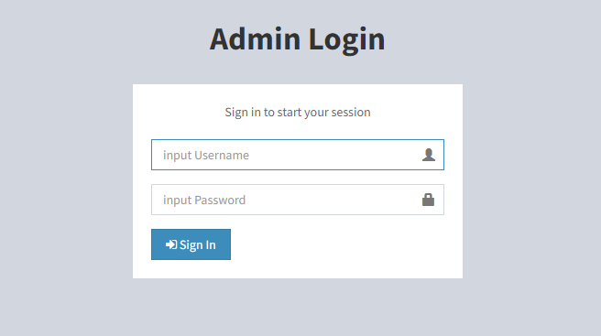1) Admin Login Page

Figure 6: Admin login page

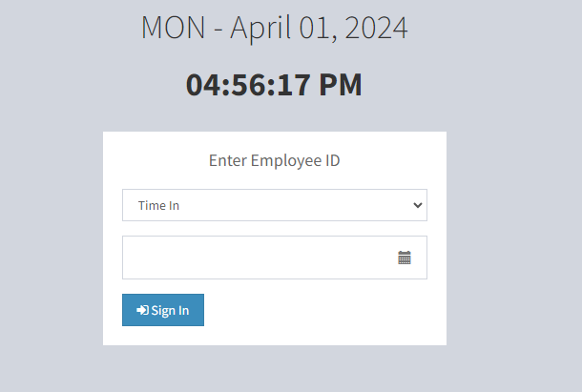2) Employee attendance page

Figure 7: Employee attendance page

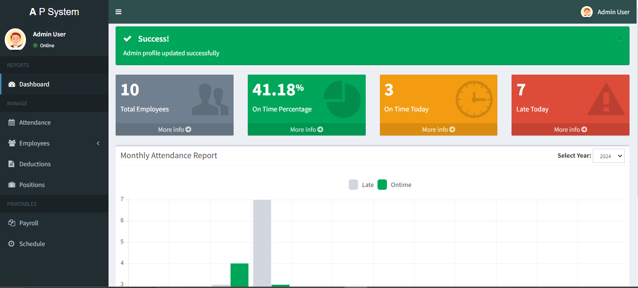3) Dashboard

Figure 8: Dashboard

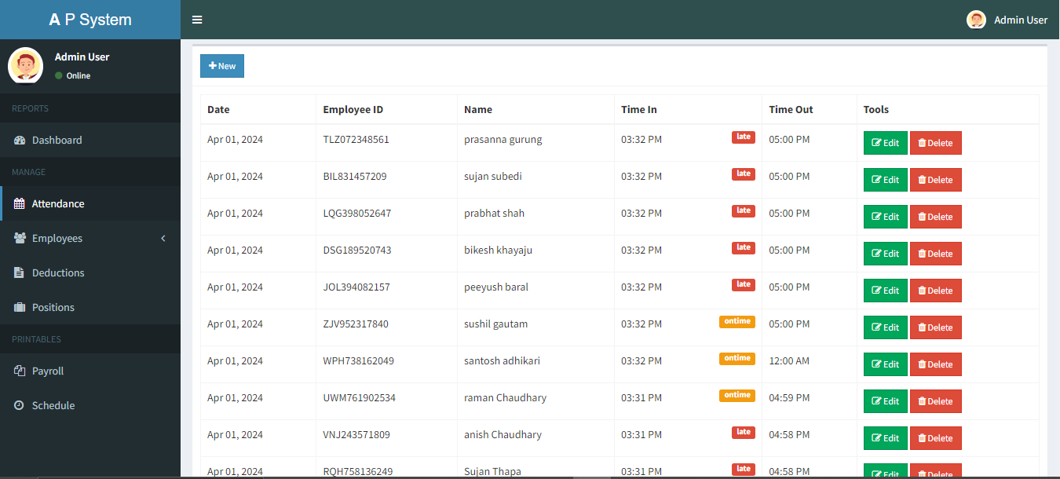4) Attendance list

Figure 9: Attendance list

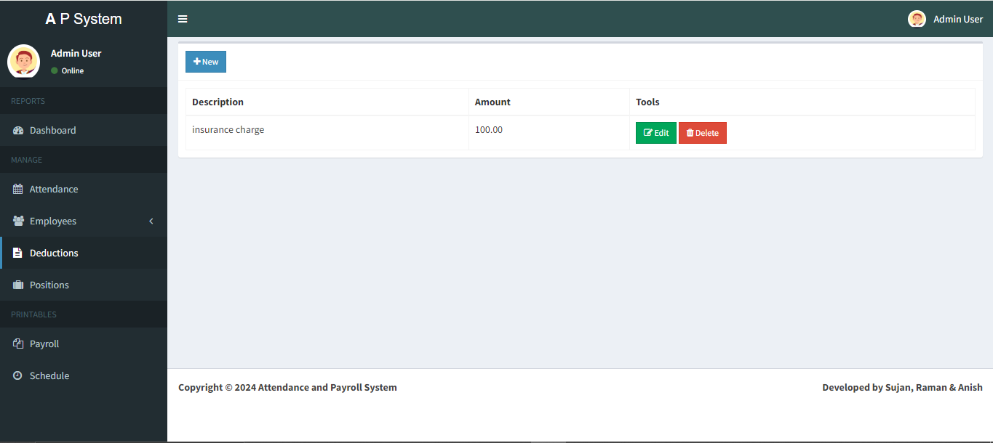5) Deduction list page

Figure 10: Deduction details

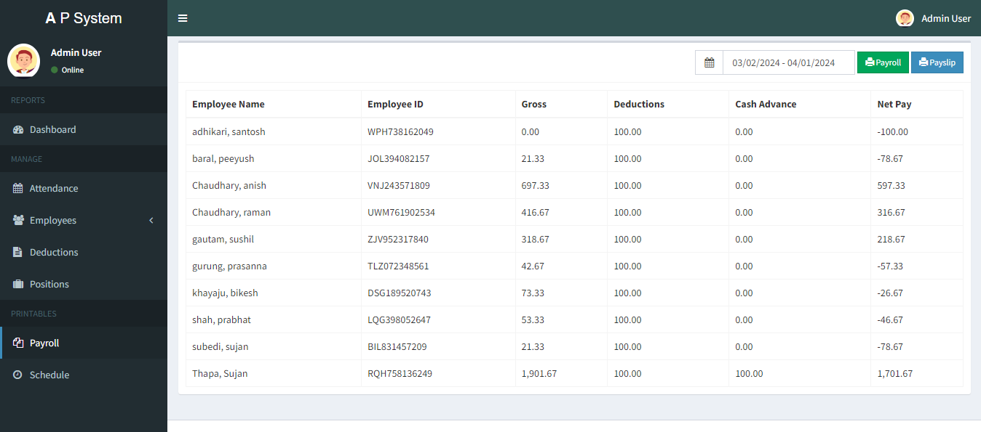6) Employee Payroll list Page

Figure 11: Employee payroll list

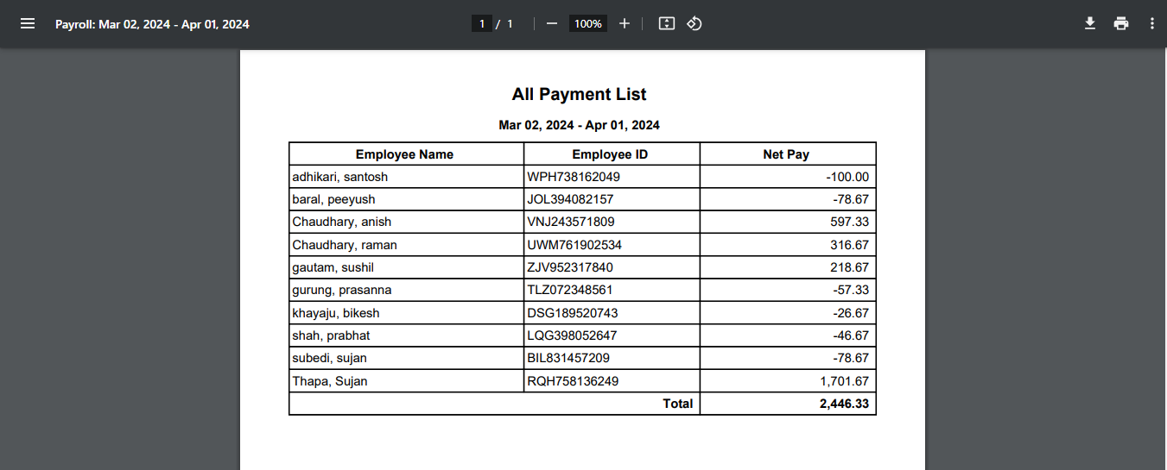7) Employee payroll list pdf

Figure 12: Employee payroll

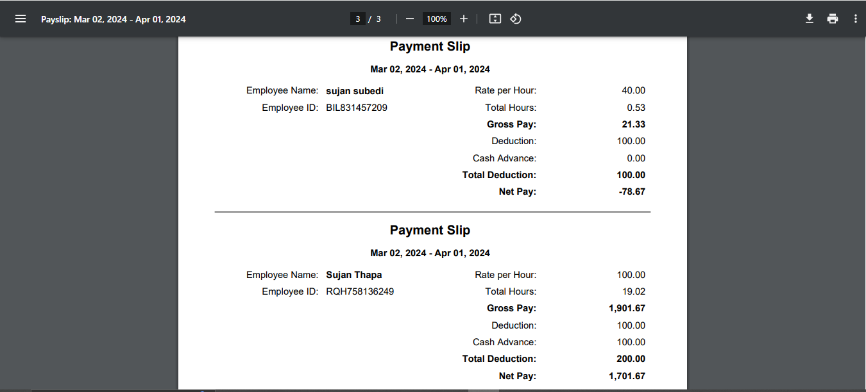8) Payment slip 1

Figure 13: Employee payment slip 1

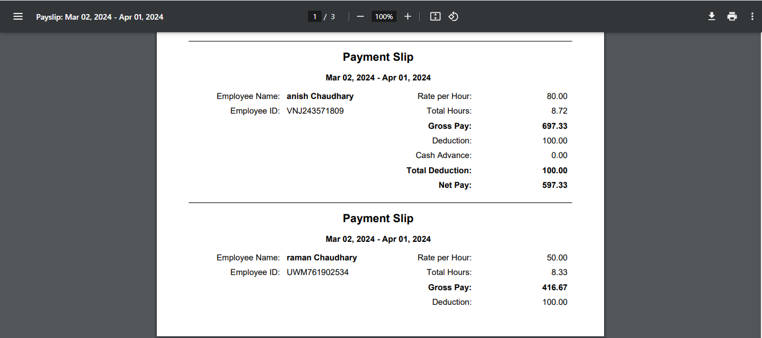9) Payment slip 2

Figure 14: Employee payment slip 2

10) Admin table



Figure 15: Admin table

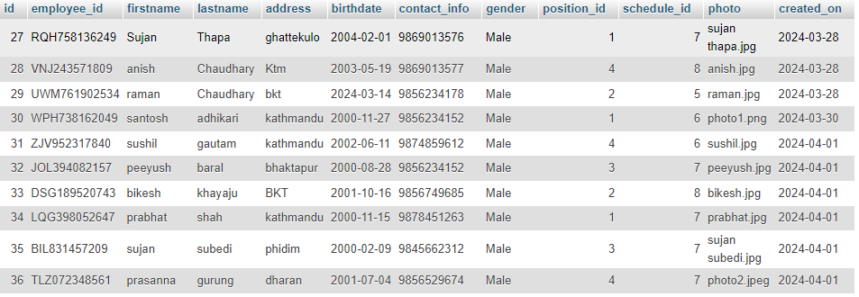11) Employee table

Figure 16: Employee table